LAB1: Temperature Sensor with Relay Control (Telegram)

Task 1-Sensor Read & Print

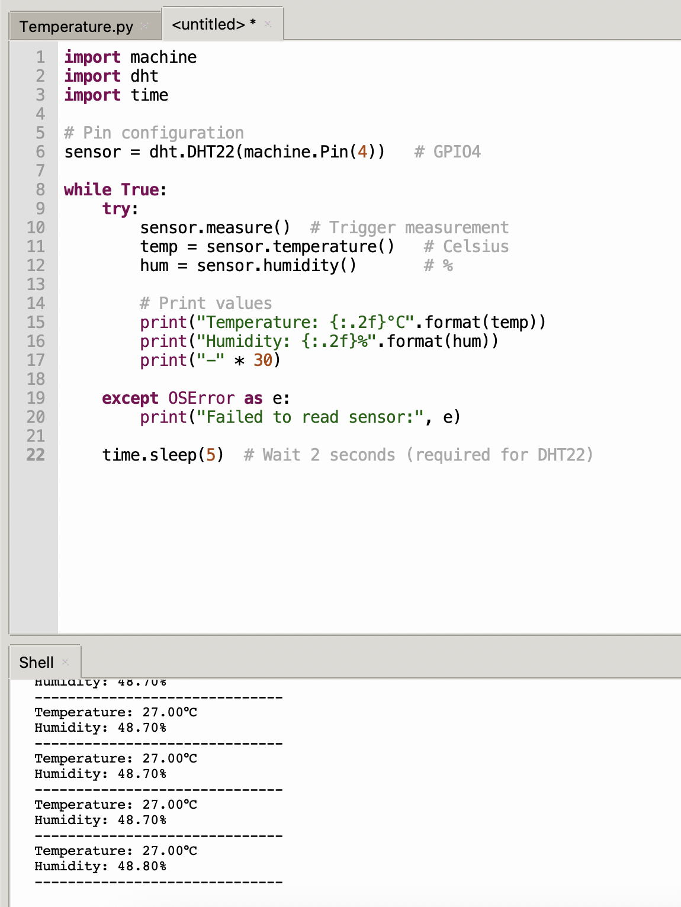
Task 2-Telegram Send

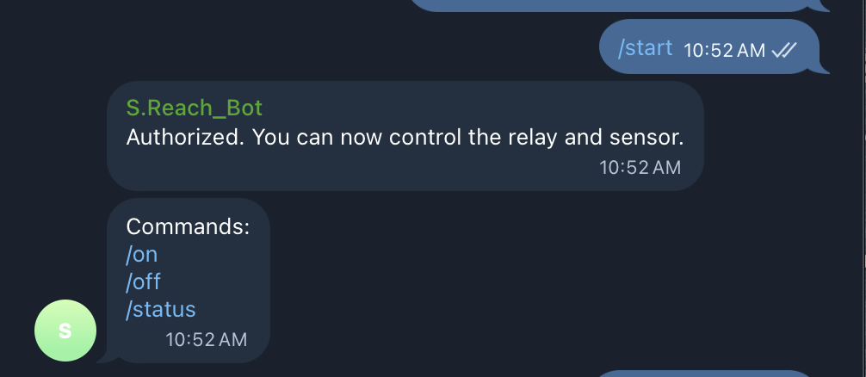
Task 2-Telegram Send

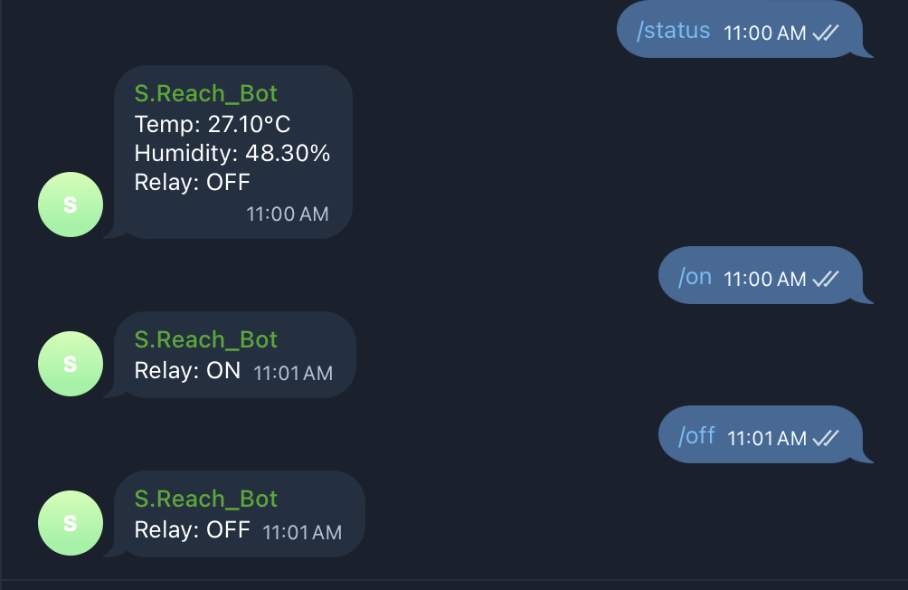

Task 4-Bot Command

